Memory Management in Android

References:
https://developer.android.com/topic/performance/memory-overview
https://developer.android.com/topic/performance/memory-management

Memory allocation among processes:

The Android platform runs on the premise that free memory is wasted memory. It tries to use all of the available memory at all times.

Types of Memory:
Android devices contain three different types of memory: RAM, zRAM, and storage.
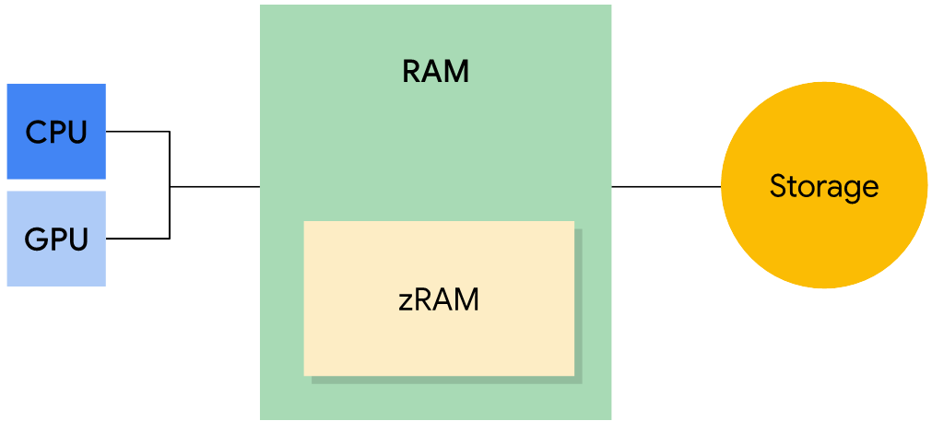

- RAM is the fastest type of memory, but is usually limited in size. High-end devices typically have the largest amounts of RAM.
- zRAM is a partition of RAM used for swap space. Everything is compressed when placed into zRAM, and then decompressed when copied out of zRAM. This portion of RAM grows or shrinks in size as pages are moved into or taken out of zRAM. Device manufacturers can set the maximum size.
- Storage contains all of the persistent data such as the file system and the included object code for all apps, libraries, and the platform. Storage has much more capacity than the other two types of memory. On Android, storage isn’t used for swap space like it is on other Linux implementations since frequent writing can cause wear on this memory, and shorten the life of the storage medium.

Memory Pages:
"kswapd" --> kernel swap daemon
RAM is broken up into pages. Typically each page is 4KB of memory.
Free pages are unused RAM. Used pages are RAM that the system is actively using, and are grouped into the following categories:
Cached Memory, Anonymus Memory
- Catched Memory : Backed by a file on Storage.(Code or memory map file)
- Private Catched Memory: Owned by process and not shared
  - Clean: Unmodified copy of file on storage and can be deleted by "kswapd" to increase memory.
  - Dirty : Modified copy of file on storage; can be moved to or compressed in, zRam by "kswapd" to increase free memory
- Shared Catched Memory: Used by multiple processes
  - Clean: Unmodified copy of the file on storage,c an be dleeted by "kswapd" to increase the memory
  - Dirty: modified copy of file on storage; allows changes to be written back to the file in storage to increase free momory by "kswapd", or explicitly using msync() or munmap()
  - Anonymus: Memory not backed by a file on storage
    - these are always dirty and can be moved in zRAM by "kswapd" to increase memory
Clean pages contain an exact copy of a file (or portion of a file) that exists in storage. A clean page becomes a dirty page when it no longer contains an exact copy of the file

Low Memory Management

1) Karnel swap daemon:
kswapd can reclaim clean pages by deleting them because they're backed by storage and have not been modified.
Kswapd can move dirty pages and anonymus dirty pages to zRAM, where they are compressed. If the Process assosiated with a compressed page is killed then the page deleted from zRAM.

2) Low-memory killer:
Many times, kswapd cannot free enough memory then system notify app by calling "onTrimMemory()" that memory is running low and it should reduce its allocations. And if this is not sufficient kernel starts killing processes.
To decide which process to kill LMK uses an out of memory score "oom_adj_score" to prioritize the running processes.
And high score processes are killed first.
Kill prioritize in this order ::
- Background apps – that are no longer in use and are in background
- Previous app – most recent used app
- Home app
- Services – started by app like syncing to cloud etc.
- Perceptible apps – like listining music
- Foreground app: Currently running app
- Persistent Services – core services of device like telephony, bluetooth, messaging, wifi, network etc.
- System: System Processes killed then phone appear to reboot
- Native: Very low level processes used by system like kswapd

Calculating Memory Footprint
https://developer.android.com/topic/performance/memory-management#calculating_memory_footprint

adb shell dumpsys meminfo -s [process]

